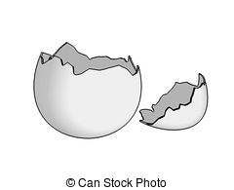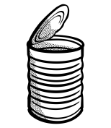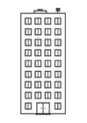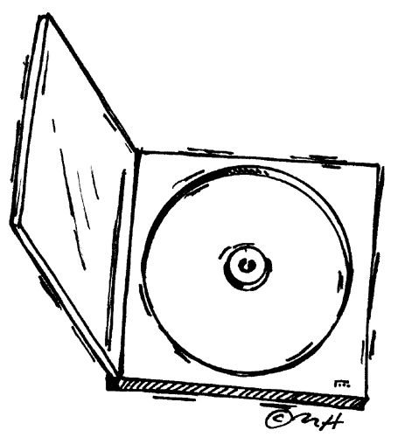

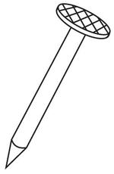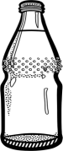

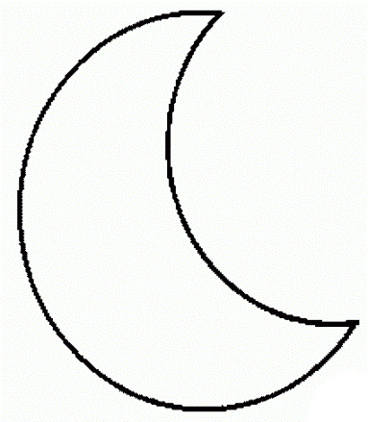

Abfall & Weltraum ABC

A = Astronaut B = Bananenschale C = CD-Hülle

D = Dose E = Eierschale F = Flasche

G = Gabel H = Hochhaus I = Indianer

J = Joghurtbecher K = Käse L = Luftbalon

M = Mond N = Nagel O = Olchi

P = Plasticksack R = Rakete S = Stern

T = Teleskop U = Unterhose W = Wolke

Z = Zahnbürste

